***Mini Project 3: Telecom Billing System***
Theory:
We are going to create a basic Telecom Billing System using the C programming language. This system allows users to perform operations such as adding new customer records, viewing the list of records, modifying existing records, viewing payment details, searching for specific records, and deleting records.

What is a Telecom Billing System?
Telecom service is one of the biggest services having millions of users and the data managed by these companies are quite large so, we need some software system to efficiently manage this data.
A telecom billing system is a digital system to keeps track of user, their service usage and their pending bill. It is able to store and manage data of multiple users and helps the telecom provider automate the billing of the services from the customer.

Operations Offered by Telecom Billing System
The following are the operations and functionalities offered by the telecom billing system.
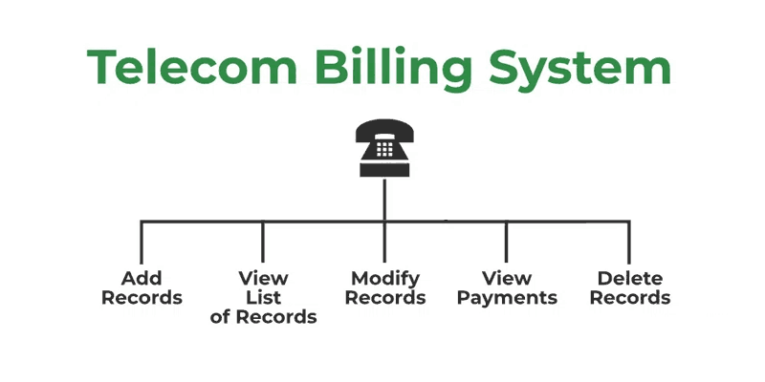
- Add New Record: Add new customer record.
- View List of Records: View all the records at a glance.
- Modify Record: Modification of an already existing record.
- View Payment: View the bill for a given customer.
- Delete Record: The deletion of a record from the memory.
Prerequisites: This project requires you to have a basic understanding of the C programming language concepts such as arrays, strings, structs, etc.

Components of the Telecom Billing System Program
The telecom billing system is divided into multiple components each performing a specific task.

Necessary Libraries
We will use the following libraries:
- <stdio.h>: For Input and Output
- <string.h>: For String Manipulation
Both of these are standard libraries that come bundled with the C compiler.

Data Structure to Hold Customer Information
- A structured Customer is defined as holding information about a customer.
- Array customers[100] of type Customer is created to store customer records. It can hold up to 100 records.
- customerCount is an integer variable used to keep track of the number of customers.

Code:

#include <stdio.h>
#include <string.h>

// Structure to hold customer information
struct Customer {
char name[50];
char phoneNumber[15];
float usage;
float totalBill;
};

struct Customer
customers[100]; // Array to store customer data
int customerCount = 0; // Variable to keep track of the
// number of customers

// Function to add a new customer record
void addRecord()
{
if (customerCount < 100) {
printf("\nEnter name: ");
scanf(" %[^\n]s", customers[customerCount].name);
printf("Enter phone number: ");
scanf("%s", customers[customerCount].phoneNumber);
printf("Enter usage (in minutes): ");
scanf("%f", &customers[customerCount].usage);
customers[customerCount].totalBill
= customers[customerCount].usage * 0.1;
customerCount++;
printf("\nRecord added successfully!\n");
}
else {
printf("\nMaximum number of records reached!\n");
}
}

// Function to view the list of customer records
void viewRecords()
{
printf("\nName\tPhone Number\tUsage(min)\tTotal "
"Bill($)\n");
for (int i = 0; i < customerCount; i++) {
printf("%s\t%s\t%.2f\t\t%.2f\n", customers[i].name,
customers[i].phoneNumber, customers[i].usage,
customers[i].totalBill);
}
}

// Function to modify a customer record
void modifyRecord(char phoneNumber[])
{
for (int i = 0; i < customerCount; i++) {
if (strcmp(customers[i].phoneNumber, phoneNumber)
== 0) {
printf(
"\nEnter new usage (in minutes) for %s: ",
customers[i].name);
scanf("%f", &customers[i].usage);
customers[i].totalBill
= customers[i].usage * 0.1;
printf("\nRecord modified successfully!\n");
return;
}
}
printf("\nRecord not found!\n");
}

// Function to view payment for a customer
void viewPayment(char phoneNumber[])
{
for (int i = 0; i < customerCount; i++) {
if (strcmp(customers[i].phoneNumber, phoneNumber)
== 0) {
printf(
"%s\t%s\t%.2f\t\t%.2f\n", customers[i].name,
customers[i].phoneNumber,
customers[i].usage, customers[i].totalBill);
return;
}
}
printf("\nRecord not found!\n");
}

// Function to delete a customer record
void deleteRecord(char phoneNumber[])
{
for (int i = 0; i < customerCount; i++) {
if (strcmp(customers[i].phoneNumber, phoneNumber)
== 0) {
for (int j = i; j < customerCount - 1; j++) {
customers[j] = customers[j + 1];
}
customerCount--;
printf("\nRecord deleted successfully!\n");
return;
}
}
printf("\nRecord not found!\n");
}

// Function to display menu options
void displayMenu()
{
printf("\n1. Add New Record\n");
printf("2. View List of Records\n");
printf("3. Modify Record\n");
printf("4. View Payment\n");
printf("5. Delete Record\n");
printf("6. Exit\n");
}

int main()
{
int choice;
char phoneNumber[15];

while (1) {
displayMenu();
printf("Enter your choice: ");
scanf("%d", &choice);

switch (choice) {
case 1:
addRecord();
break;
case 2:
viewRecords();
break;
case 3:
printf(
"\nEnter phone number to modify record: ");
scanf("%s", phoneNumber);
modifyRecord(phoneNumber);
break;
case 4:
printf(
"\nEnter phone number to view payment: ");
scanf("%s", phoneNumber);
viewPayment(phoneNumber);
break;
case 5:
printf(
"\nEnter phone number to delete record: ");
scanf("%s", phoneNumber);
deleteRecord(phoneNumber);
break;
case 6:
return 0;
default:
printf("\nInvalid choice! Please try again.\n");
}
}

return 0;
}

